**Supplementary Materials for**

**Protected area planning to conserve biodiversity in an uncertain world**

Richard Schuster, Rachel Buxton, Jeffrey O. Hanson, Allison D. Binley, Jeremy Pittman, Vivitskaia Tulloch, Frank A. La Sorte, Patrick R. Roehrdanz, Peter H. Verburg, Amanda D. Rodewald, Scott Wilson, Hugh P. Possingham, Joseph R. Bennett

Correspondence to: [richard.schuster@glel.carleton.ca](mailto:richard.schuster@glel.carleton.ca)

**This PDF file includes:**

Supplementary Figures 1 to 9

Supplementary Tables 1 to 4

**Supplementary Figure 1. Governance risk (yellow = low, blue= high)**

**Supplementary Figure 2. Land systems risk (yellow = low, blue= high)**

**Supplementary Figure 3. Climate risk (climate velocity) (yellow = low, blue= high)**



**Supplementary Figure 4. Scenario overlap. green = protected areas. Color gradient from yellow (one scenario) to red (15 scenarios) = overlap.**

**Supplementary Figure 5. Areas of high scenario overlap (>10 scenarios, green) compared to biodiversity hotspots (*28*) (blue).**

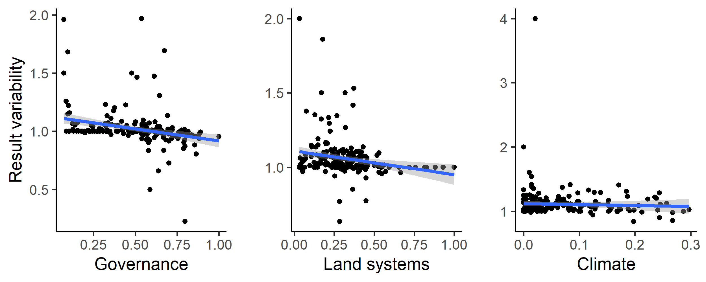

**Supplementary Figure 6. Influence of average country specific risk factors on the optimization outcomes compared between null scenario and the scenarios including one of the risk factors. Each data point represents the results for one country. The fitted blue lines and 95% confidence bands are from ordinary least-squares regression.**

**Supplementary Figure 7. Alternative climate risk metric (extreme heat events) (yellow = low, blue= high)**

**Supplementary Figure 8 Alternative climate risk scenario “No regrets” areas that were identified as priority habitat for protection regardless of the risks included in our analysis.**

**Supplementary Figure 9. Alternative climate risk scenarios percent country-level variation between the null scenario and the 15 scenarios including risk. Countries whose results are consistent across the 15 scenarios (e.g., Brazil) have low variation, while countries whose results are less consistent across the 15 scenarios (e.g., Sweden) have high variation. The kmeans method (*37*) was used to generate class intervals for visualization.**

**Supplementary Table 1. Scenarios explored and global protection results. The risk factor order represents the order risk factors were included in the hierarchical prioritization. (G = governance, L = land use, C = Climate).**

|  |  |  |
| --- | --- | --- |
| **Scenario** | **Risk factors included** | **Global land area protected [%]** |
| **null** | - | 21.27 |
| **1** | G | 21.35 |
| **2** | L | 22.31 |
| **3** | C | 23.79 |
| **4** | G > L | 21.93 |
| **5** | L > G | 22.18 |
| **6** | G > C | 23.78 |
| **7** | C > G | 23.31 |
| **8** | L > C | 23.52 |
| **9** | C > L | 22.99 |
| **10** | G > L > C | 23.52 |
| **11** | G > C > L | 23 |
| **12** | L > G > C | 23.5 |
| **13** | L > C > G | 23.08 |
| **14** | C > G > L | 22.3 |
| **15** | C > L > G | 22.99 |

**Supplementary Table 2**. **Country specific results for the 15 scenarios investigated. Numbers represent % of land area of a country selected (including existing protected areas).  
(As an example 5 countries included here, full list in csv. N = null, G = governance, L = land use, C = Climate)**   
<https://drive.google.com/file/d/1eD4y4K8XG4nxnRL5fNtiTqzuqfIJ_DfB/view?usp=sharing>

|  |  |  |  |  |  |
| --- | --- | --- | --- | --- | --- |
|  | Afghanistan | Åland | Albania | Algeria |  |
| N | 15.95 | 57.14 | 38.46 | 10.62 |  |
| G | 14.95 | 85.71 | 35.66 | 7.71 |  |
| L | 17.03 | 85.71 | 43.71 | 10.32 |  |
| C | 19.25 | 57.14 | 46.15 | 13.69 |  |
| GL | 15.87 | 85.71 | 37.41 | 8.94 |  |
| LG | 16.55 | 100 | 38.11 | 11.59 |  |
| GC | 19.3 | 57.14 | 46.5 | 13.71 |  |
| CG | 17.89 | 71.43 | 39.16 | 12.74 |  |
| LC | 17.8 | 71.43 | 44.06 | 13.07 |  |
| CL | 19.52 | 57.14 | 40.56 | 13.36 |  |
| GLC | 17.8 | 57.14 | 43.71 | 13.15 |  |
| GCL | 19.44 | 57.14 | 41.96 | 13.38 |  |
| LGC | 17.81 | 57.14 | 44.06 | 13.05 |  |
| LCG | 16.58 | 85.71 | 38.11 | 12.36 |  |
| CGL | 17.52 | 85.71 | 43.36 | 12.4 |  |
| CLG | 19.52 | 57.14 | 40.56 | 13.36 |  |

**Supplementary Table 3. Governance risk score table (see csv)**

**(As an example Afghanistan – Barbados are included below)**<https://drive.google.com/file/d/1g_LePBfCbphXzTiCOXCzQtNLSSYoV6me/view?usp=sharing>

|  |  |  |  |
| --- | --- | --- | --- |
| Country.Name | Country.Code | MeanIndex | SDIndex |
| Afghanistan | AFG | -1.65038 | 0.16074 |
| Albania | ALB | -0.28043 | 0.219515 |
| Algeria | DZA | -0.86838 | 0.121774 |
| American Samoa | ASM | 0.747997 | 0.127264 |
| Andorra | AND | 1.359029 | 0.04054 |
| Angola | AGO | -1.16429 | 0.217384 |
| Anguilla | AIA | 1.138708 | 0.225908 |
| Antigua and Barbuda | ATG | 0.687351 | 0.143042 |
| Argentina | ARG | -0.19472 | 0.196541 |
| Armenia | ARM | -0.29545 | 0.091655 |
| Aruba | ABW | 1.181311 | 0.090913 |
| Australia | AUS | 1.591282 | 0.033469 |
| Austria | AUT | 1.559385 | 0.080972 |
| Azerbaijan | AZE | -0.84662 | 0.123512 |
| Bahamas, The | BHS | 0.991142 | 0.212122 |
| Bahrain | BHR | 0.067606 | 0.189151 |
| Bangladesh | BGD | -0.8678 | 0.131258 |
| Barbados | BRB | 1.154432 | 0.145899 |

**Supplementary Table 4**. **Worldwide governance indicator definitions from the World Bank (15).**

|  |  |
| --- | --- |
| **Indicator** | **Definition**  Source: World Bank, 2020 (<https://datacatalog.worldbank.org/dataset/worldwide-governance-indicators>) |
| Voice and accountability | “Voice and accountability captures perceptions of the extent to which a country's citizens are able to participate in selecting their government, as well as freedom of expression, freedom of association, and a free media.” |
| Political stability and absence of violence | “Political Stability and Absence of Violence/Terrorism measures perceptions of the likelihood of political instability and/or politically-motivated violence, including terrorism.” |
| Government effectiveness | “Government effectiveness captures perceptions of the quality of public services, the quality of the civil service and the degree of its independence from political pressures, the quality of policy formulation and implementation, and the credibility of the government's commitment to such policies.” |
| Regulatory quality | “Regulatory quality captures perceptions of the ability of the government to formulate and implement sound policies and regulations that permit and promote private sector development.” |
| Rule of law | “Rule of law captures perceptions of the extent to which agents have confidence in and abide by the rules of society, and in particular the quality of contract enforcement, property rights, the police, and the courts, as well as the likelihood of crime and violence.” |
| Control of corruption | “Control of corruption captures perceptions of the extent to which public power is exercised for private gain, including both petty and grand forms of corruption, as well as "capture" of the state by elites and private interests.” |
|  |  |